Project Design Phase-II

Solution Requirements (Functional &amp; Non-functional)
Date | 26 September 2026
Team ID | SWTID-2026-9430
Project Name | AI-BLOGNEST API
Maximum Marks | 4 Marks

Functional Requirements:

Following are the functional requirements of the proposed solution.
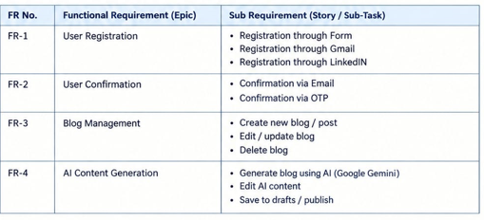

Non-functional Requirements:

Following are the non-functional requirements of the proposed solution.
